**XHAW Reflective Report**

**Introduction**

To me, Work-Integrated Learning (WIL) is all about experiencing the real world beyond the classroom. It’s a chance to apply what I’ve learned in practical situations, helping me understand how theory works in practice. WIL offers more than just knowledge – it builds confidence, teaches problem-solving, and helps me grow both professionally and personally. By working alongside professionals, I get to develop skills that can’t always be taught in a lecture. It’s a valuable opportunity to prepare for the future, connect with the industry, and gain meaningful experience that will shape my career.

**Skills Learnt**

During my WIL experience, I developed several key skills across different areas. I gained hands-on experience with tasks such as e.g., media monitoring, compiling reports, or managing social media content, which required attention to detail and alignment with industry standards. For **interpersonal communication**, I actively participated in brainstorming sessions, team meetings, and feedback discussions, where I learned to collaborate effectively, listen actively, and present my ideas clearly. Additionally, I developed essential **management skills** such as time management, ensuring I met deadlines and prioritized tasks efficiently.

**Role In The Team**

As the group manager, I played a key role in overseeing my team’s work and ensuring tasks were completed efficiently, particularly focusing on managing the website. I reported directly to the team leader, who provided instructions and guidance, while I managed communication within the group. My leadership responsibilities included delegating tasks, setting timelines, and monitoring progress to meet deadlines. I contributed to the team’s success by ensuring the website was functional, up-to-date, and aligned with project goals. The team dynamic was collaborative, with each member contributing based on their strengths. I fostered open communication, addressing concerns, complaints, and queries promptly. When conflicts or misunderstandings arose, I mediated between team members to find fair solutions, ensuring a positive and productive group environment. My role required balancing leadership with teamwork, contributing not only as a manager but also as an active and supportive team player.

**Research, technology and the presentation of information**

One scenario where I had to find relevant information was when updating the website with accurate details from the module manual based on where the information was collected from. The information was founded on the instructions module manual on what I had to present. The technology I made use of was google, as well as chatGPT and the manual module. The information I gathered had to be presented clearly in a structured format.

**Personal strengths (strong points) and weaknesses (areas to do better in)**

The tasks I did really well in was the development of the calculator, inserting of the 3 map locations as well as the navigation bar for the website and side bar and lastly the responsiveness for the website. My first strength I have is that I can work under pressure, effective time management, good communication skills, adaptability, and teamwork. I struggled with the early stages of developing the website were the responsiveness of the website and the design of making the website visually appealing for usesrs and customers. I figured the reasons I did not do well in these tasks were because at the time I did not have clear knowldege and undderstanding of what was required. How I know I can improve on my faults is by asking for assistance and by putting in more practice to better myself and understanding as well.

**Stakeholder relationship**

My relationship with the mentor was overall positive and productive. The parts that worked well included open communication, timely feedback, and clear guidance on expectations and tasks. I felt comfortable asking for help when needed and appreciated the constructive feedback that helped me improve my performance. However, there were occasional challenges when deadlines or priorities were not clearly communicated, leading to minor confusion about task expectations.

To make the relationship stronger, I could have been more proactive in seeking regular check-ins and clarifying expectations upfront. Additionally, I believe setting clearer communication routines such as scheduled feedback sessions would have enhanced our collaboration.

**Impact**

During my placement, I believe my contributions positively impacted the team. My efforts in managing the website ensured that information was up-to-date and accessible, which improved the company’s online presence and streamlined communication with clients and suppliers. To make an even greater impact, I could have identified more opportunities to improve workflows and taken more initiative in suggesting innovative solutions. Additionally, offering more frequent feedback and supporting colleagues beyond my assigned responsibilities would have further strengthened my contribution.

**Conclusion**

Overall, my WIL experience was both enriching and insightful. It provided me with the opportunity to apply theoretical knowledge in real-world scenarios, develop new skills, and strengthen existing ones, such as leadership, time management, and communication. Managing the website and working closely with my team allowed me to grow both professionally and personally.

**Links To Groups Git Repositories**

1. <https://github.com/molemo123/empoweringTHEnation>
2. <https://github.com/Raracookz/XHAW---Empowerig-The-Nation-website>

**Annexure A**

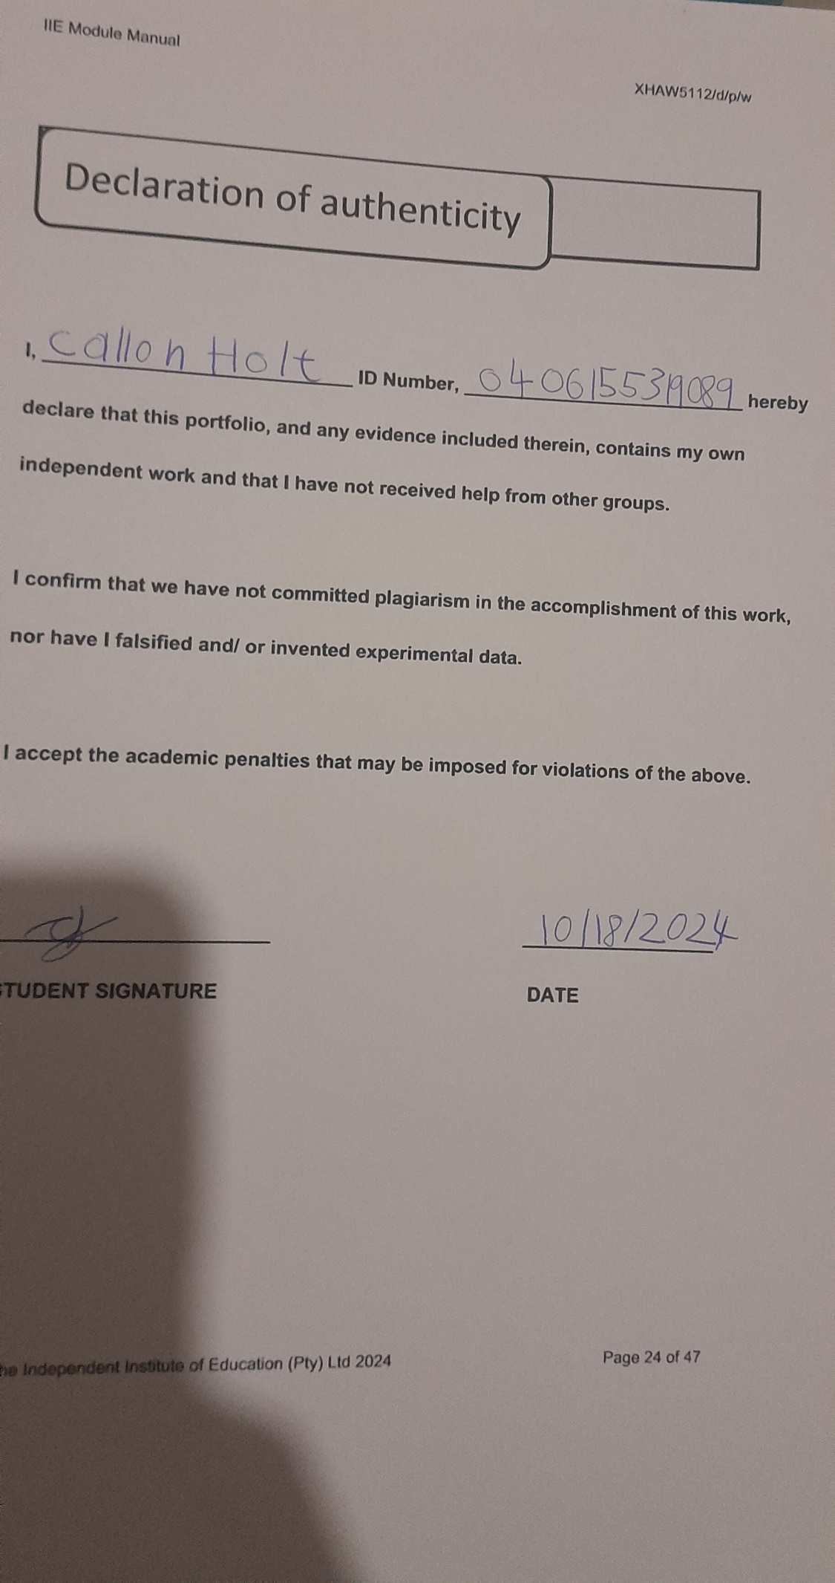

**Annexure B**



